Customer Lifetime Value Prediction

Wire Frame Documentation

As per the problem statement, we have divided analysis into three dashboards: -

1.Business Centric Dashboard

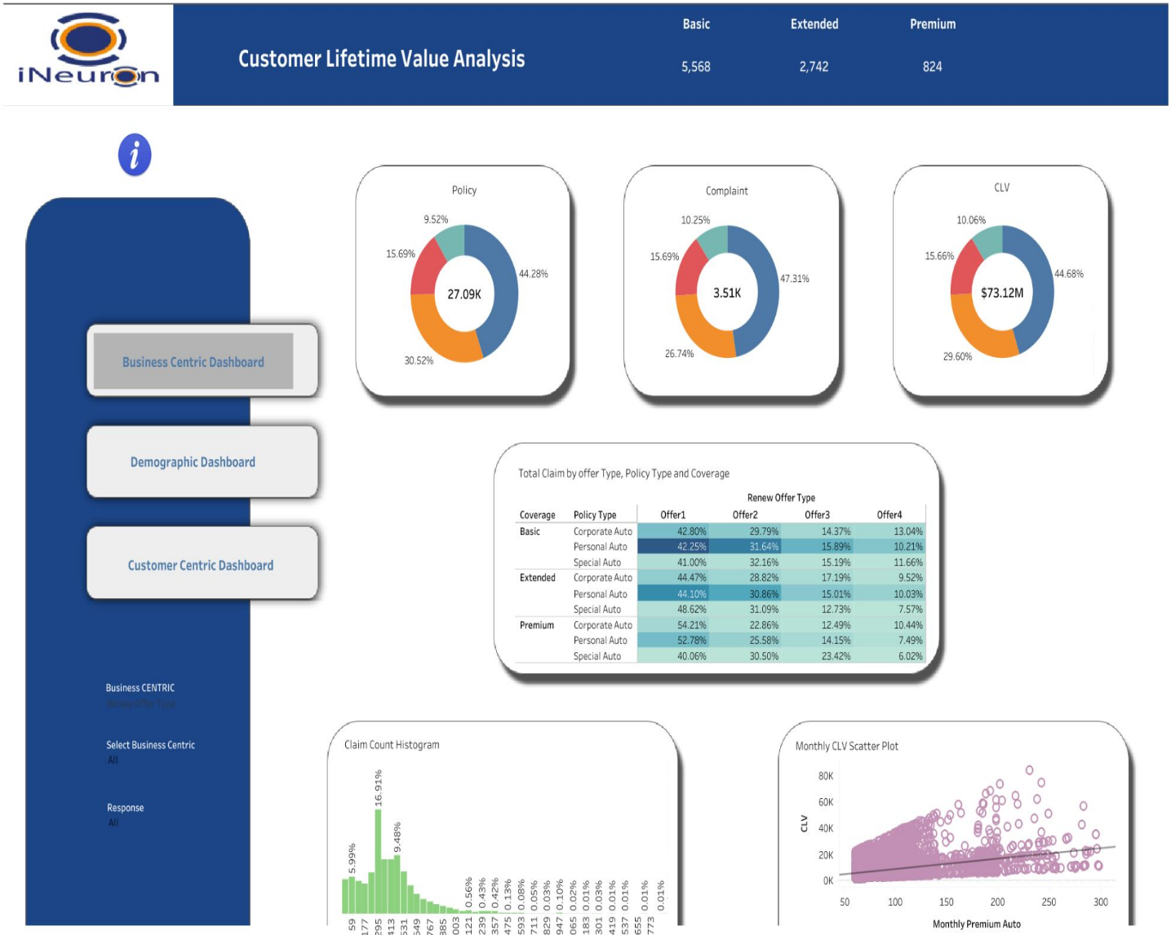

2.Demographic

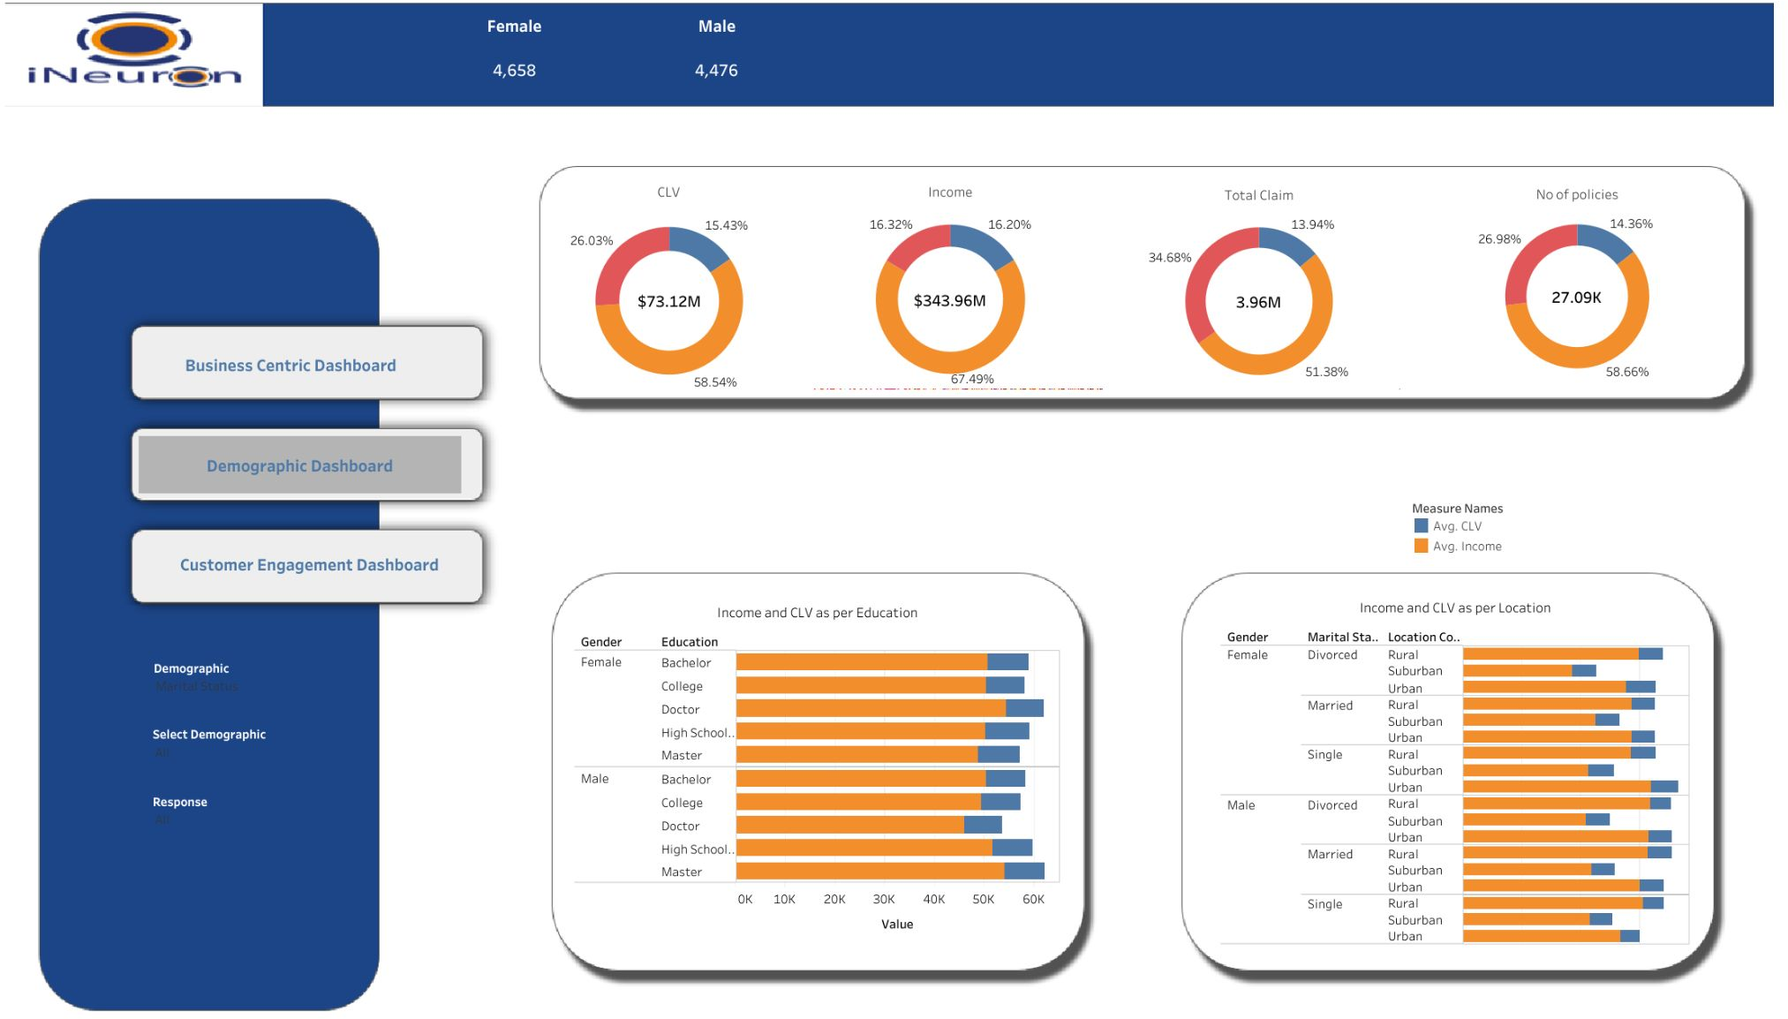

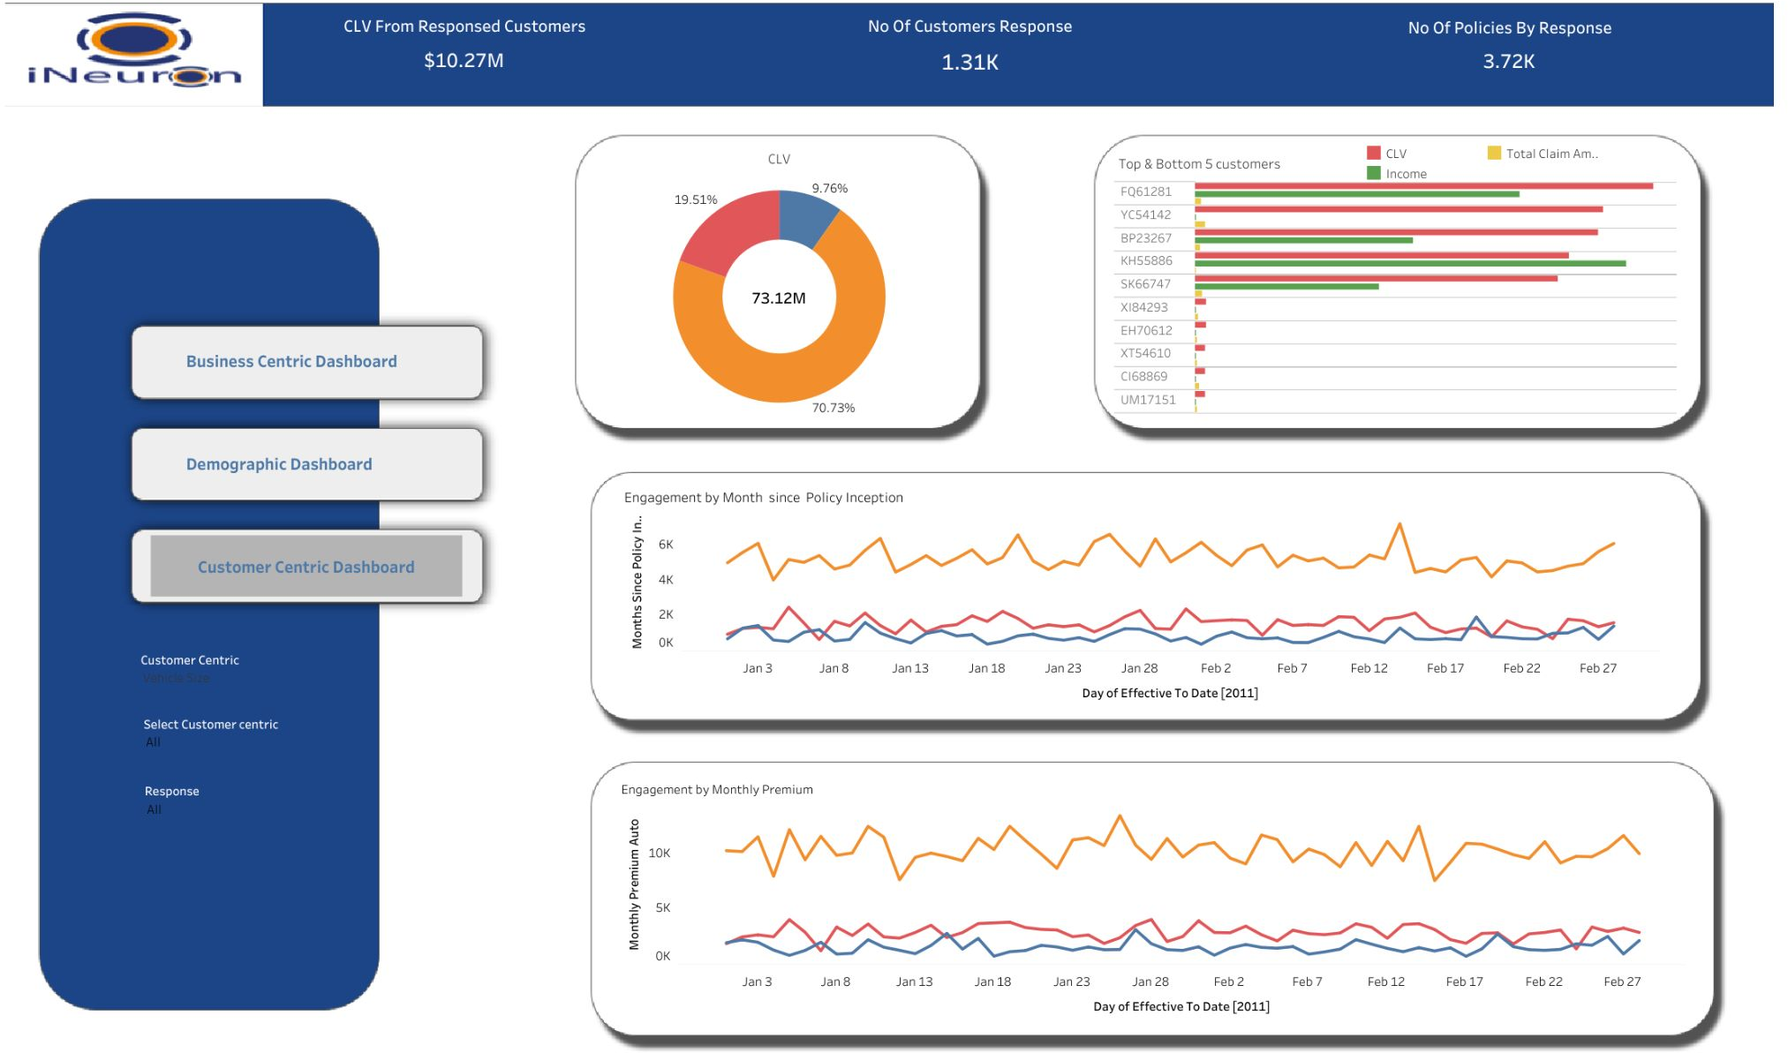Customer centric Dashboard

There is a high correlation between CLV and Monthly premium auto

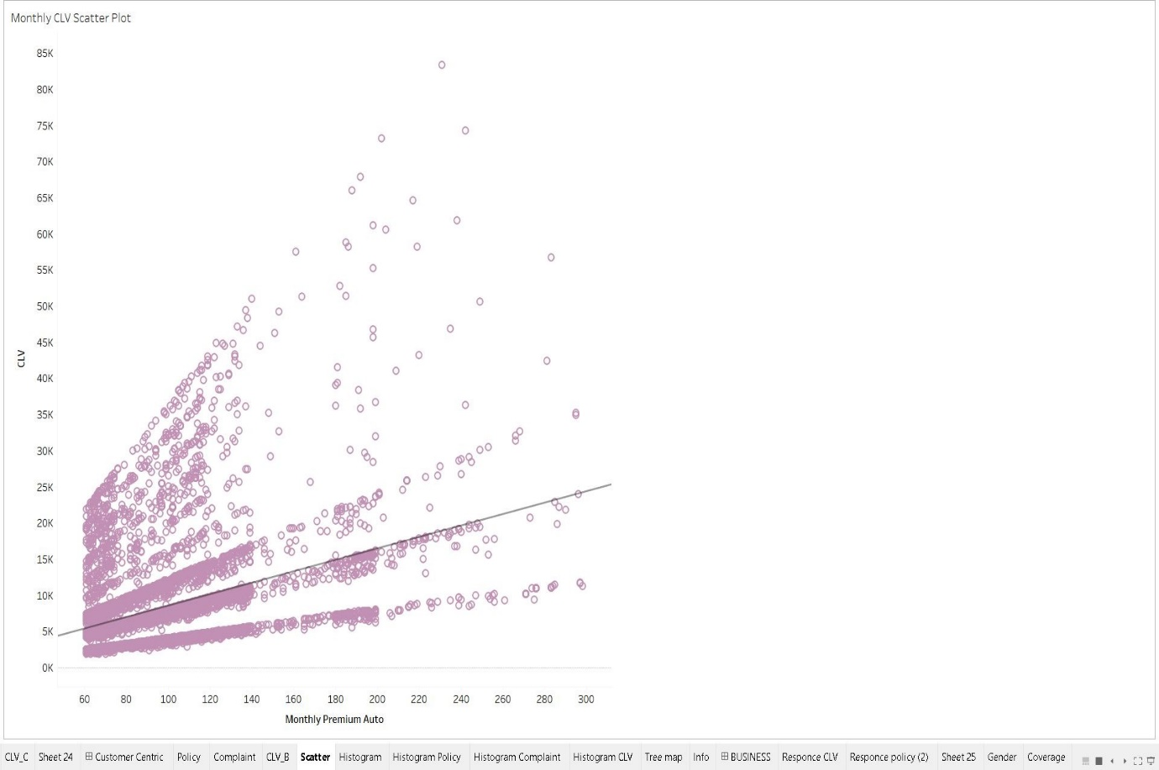

Top and Bottom 5 customers according to CLV

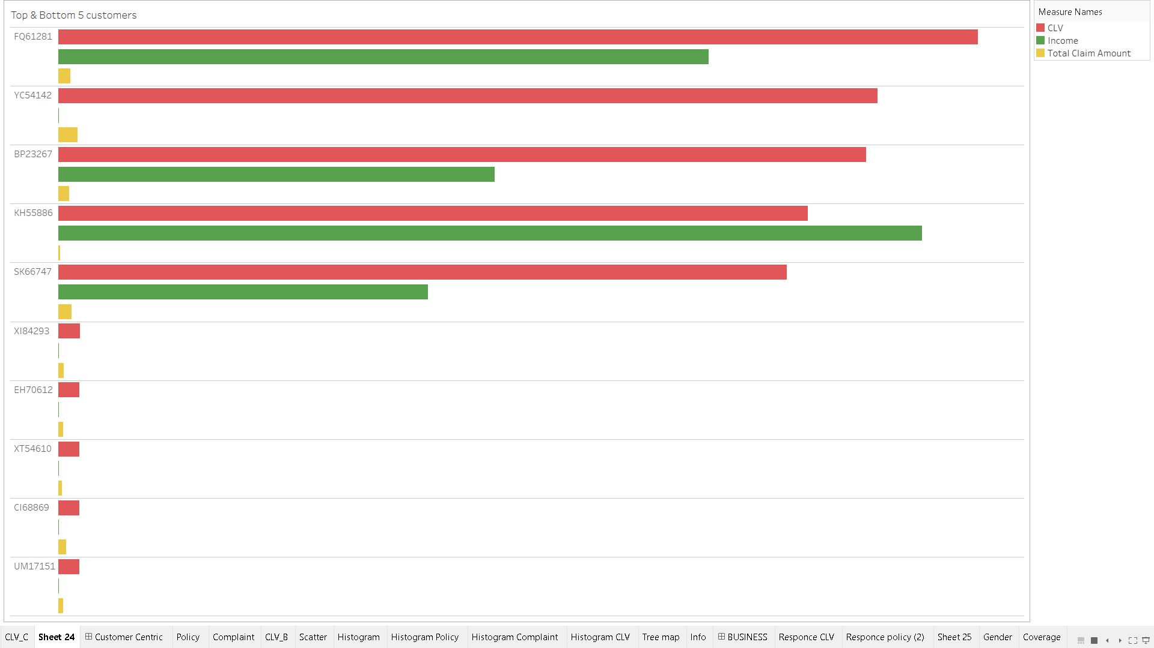

Total Claim per Business Centric Factors

